**E-Commerce Shipping Analysis**

**Project Overview**  
This project focuses on identifying key patterns and trends in e-commerce shipping data, highlighting areas for operational improvement. SQL queries are utilized for data exploration and preprocessing, while Power BI visualizations bring the insights to life through interactive dashboards.

**Dataset Description**

The dataset used in this project was sourced from Kaggle: EDA - E-commerce Shipping Data. The dataset contains 12 attributes and 10,999 observations. Key features are:

ID: Unique identifier for each customer.  
Warehouse Block: Warehouses are divided into blocks (A, B, C, D, E).  
Mode of Shipment: Delivery methods include Ship, Flight, and Road.  
Customer Care Calls: Number of customer calls regarding shipments.  
Customer Rating: Ratings on a scale of 1 (worst) to 5 (best).  
Cost of the Product: Price of the product in USD.  
Prior Purchases: Number of previous purchases made by the customer.  
Product Importance: Categories include Low, Medium, and High importance.  
Gender: Gender of the customer (Male/Female).  
Discount Offered: Discount applied to the product.  
Weight in Grams: Weight of the product in grams.  
Reached on Time: Target variable:  
0: Delivered on time.  
1: Delivery delayed.

**Step-by-Step guidelines for the project :**

-- check for duplicates

select ID,COUNT(*) from ecom_data

group by ID having COUNT(*)>1

1) --Shipment mode distribution

select Mode_of_Shipment,COUNT(*) as shipment_count from ecom_data group by Mode_of_Shipment

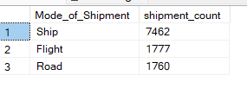

2) -- warehouse block distribution

select Warehouse_block,COUNT(*) as shipment_count from ecom_data group by Warehouse_block

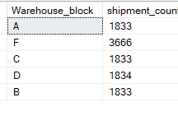

3) --Delay rate per warehouse

select Warehouse_block,AVG(1-Reached_on_Time_Y_N) as Avg_delay_rate from ecom_data group by Warehouse_block

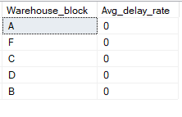

4) --Avg product cost per importance

select Product_importance,AVG(Cost_of_the_Product) as average_product_cost from ecom_data

group by Product_importance

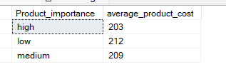

5) --Complaints vs delivery

select Customer_care_calls,AVG(Reached_on_Time_Y_N) as average_time_Y_N from ecom_data

group by Customer_care_calls

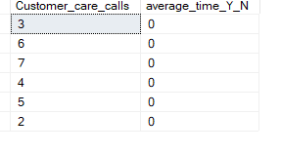

6) --Discount vs delay

select Discount_offered,AVG(1-Reached_on_Time_Y_N) as average_discount_offer from ecom_data

group by Discount_offered

7) ----Analyze the distribution of warehouse blocks:

select Warehouse_block,COUNT(*) as warehous_block

from ecom_data

group by Warehouse_block

order by Warehouse_block desc;

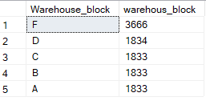

8) ----Customer Rating Distribution

select Customer_rating,COUNT(*) as rating

from ecom_data

group by Customer_rating

order by Customer_rating Asc

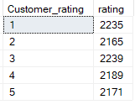

9) ----Product Importance

select Product_importance,COUNT(*) as count_importence

from ecom_data

group by Product_importance

order by Product_importance

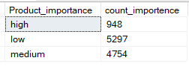

10) -- gender disribution

select Gender,COUNT(*) as gender_distribution

from ecom_data

group by Gender

order by gender_distribution desc

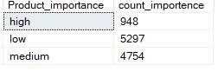

11) -- --On-Time vs. Late Deliveries

select Reached_on_Time_Y_N,COUNT(*) as on_time

from ecom_data

group by Reached_on_Time_Y_N

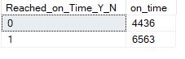

12) ----Average Discount by Delivery Status

select Reached_on_Time_Y_N,AVG(Discount_offered) as average_dicount

from ecom_data

group by Reached_on_Time_Y_N

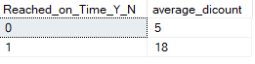

12) ----Average Product Cost by Delivery Status

select Reached_on_Time_Y_N,AVG(Cost_of_the_Product) as average_product

from ecom_data

group by Reached_on_Time_Y_N

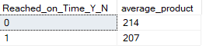

13) --High-Risk Warehouse Blocks

select Warehouse_block,

round(SUM(Reached_on_Time_Y_N)*100.0 /COUNT(*),1) as delayedpercentage

from ecom_data

group by Warehouse_block

order by delayedpercentage

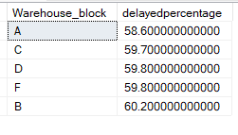

14) --Shipment Mode with Most Delays

select Mode_of_Shipment,

round(SUM(Reached_on_Time_Y_N)*100.0 /COUNT(*),1) as shipment_mode

from ecom_data

group by Mode_of_Shipment

order by shipment_mode desc

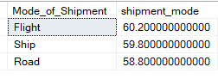

15) --Correlation Between Discounts and Delays

select Reached_on_Time_Y_N,

AVG(Discount_offered) as average_discount,

AVG(Cost_of_the_Product) as averageCostByProduct,

AVG(Weight_in_gms) as average_weight

from ecom_data

group by Reached_on_Time_Y_N

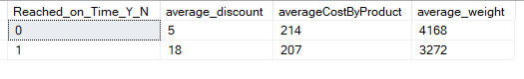

16) --Cost vs. Rating Analysis

select Customer_rating,

AVG(Cost_of_the_Product)

from ecom_data

group by Customer_rating

order by Customer_rating

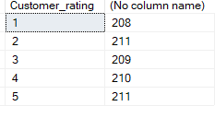

17) --Average Customer Rating by Warehouse

select Warehouse_block,

AVG(Customer_rating) as AvgRating

from ecom_data

group by Warehouse_block

order by AvgRating

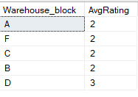

18) --Delays by Shipment Mode

select Mode_of_Shipment,

COUNT(*) NoOfShipment,

SUM(Reached_on_Time_Y_N) as DelayedSum,

round(SUM(Reached_on_Time_Y_N)*100.0/COUNT(*),2) as DelayedPercent

from ecom_data

group by Mode_of_Shipment

order by DelayedPercent desc

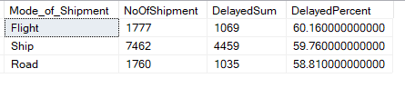

19) --Correlation Between Customer Care Calls and Delays

select Customer_care_calls,

COUNT(*) as totalorders,

SUM(case when Reached_on_Time_Y_N=1 then 1 else 0 end) as Delays,

round(SUM(case when Reached_on_Time_Y_N=1 then 1 else 0 end)*100.0 /COUNT(*),2) as DelaysPercent

FROM ecom_data

group by Customer_care_calls

order by Customer_care_calls

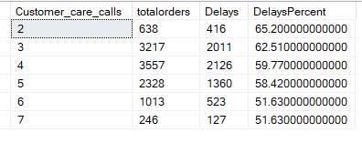

20) ----Impact of Prior Purchases on Delivery Time

select Prior_purchases,

COUNT(*) as totalPrior,

SUM(case when Reached_on_Time_Y_N=1 then 1 else 0 end) as PriorPurchases,

round(SUM(case when Reached_on_Time_Y_N=1 then 1 else 0 end)*100.0/COUNT(*),2) as PriorPurchasesPercent

from ecom_data

group by Prior_purchases

order by Prior_purchases

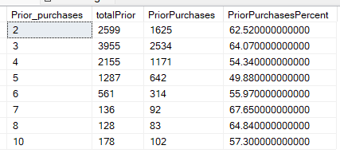

21) --Combining Shipment Mode and Product Importance

select

Mode_of_Shipment,

Product_importance,COUNT(*) as TotalShipments,

SUM(case when Reached_on_Time_Y_N=1 then 1 else 0 end) as totalDelayed,

round(SUM(case when Reached_on_Time_Y_N=1 then 1 else 0 end)*100.0/COUNT(*),2) as totalDelayedpercent

from ecom_data

group by Mode_of_Shipment,Product_importance

order by totalDelayedpercent desc

